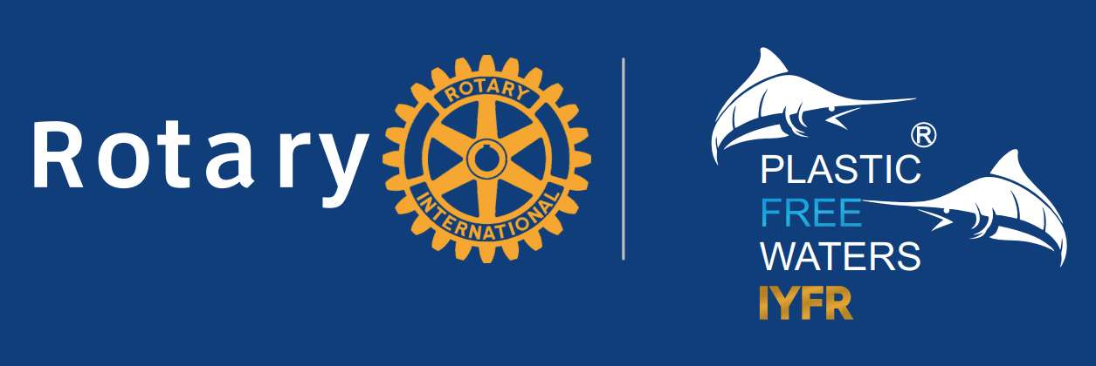

I n v i t a t i o n
we invite You to participate

Rotary Charity Regatta B2B
October 19th till 21th, 2024. Biograd-Kornati
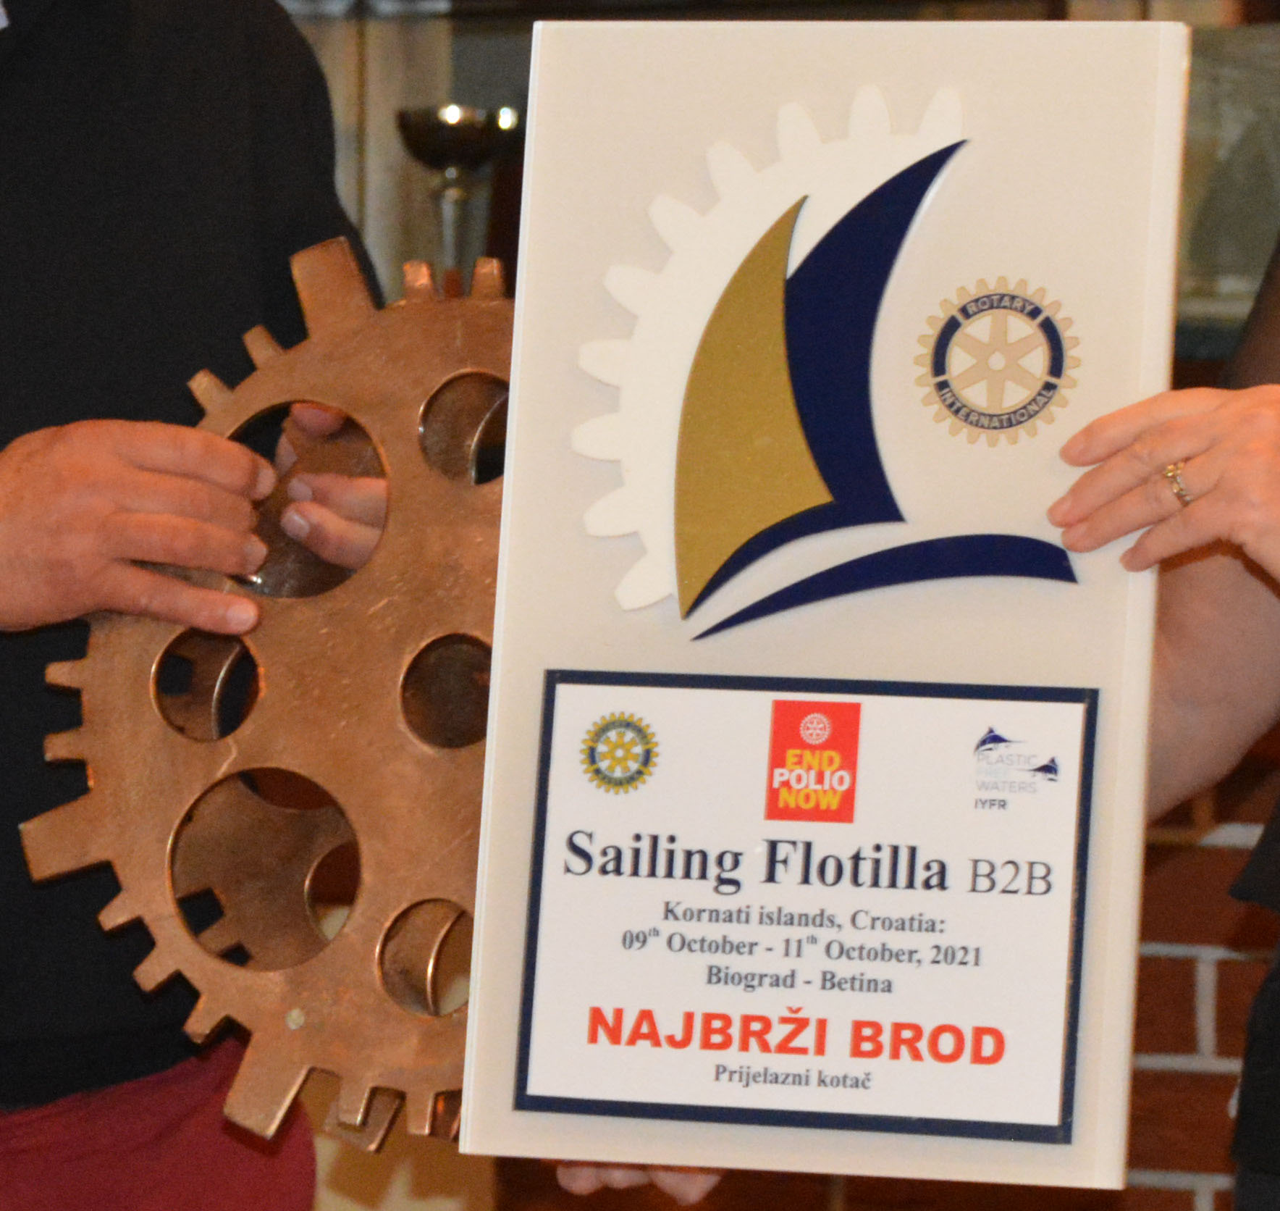
120 trees for 120 rotary years
Saturday, 19th October
14:00 Vinarija Baraka - Vodice / tasting of wine and olive oil - fingerfood 25€
19:00 Regatta opening - Clubs presentation
20:00 Restaurant - opening of the regatta,
presentation, and crew filming, dinner and wine auction, music

Sunday, 20th October
10:00 Marina Biograd - skipper's meeting and start of the regatta
20:00 Sali - Dugi otok, Kornati - catamaran party, music and lottery

Monday, 21th October
08:30 Sali - skipper's meeting and start of the regatta
18:00 Marina Kornati - dinner, distribution of awards and trophies

Registration fee €190 (01.06:)-217€ till week before regatta, after 280€ per person depending on the date of payment.
Rental Can be arranged through IYFR -Croatia
Payments to: Yachting Center Biograd, 23210 Biograd, Ul. K.P. Splitska 15,
IBAN HR4323600001102490053 swift:ZABAHR2X
Reference number: Purpose of payment: Registration fee for the regatta

The regatta program is subject to change due to weather conditions.
Organizational committee: Gordan Borčilo, Vladimir Bulić, Dragan Pavelin RC Kaštela, Davor Poljak RC ZG Sesvete, Hrvoje Vojak RC Karlovac, Marko Čićin-Šain RC ZG Metropoliten, Danilo Novakovič RC LJ Zgornji Brnik, Robert Stezinar RC ZG Candor
Applications and information:


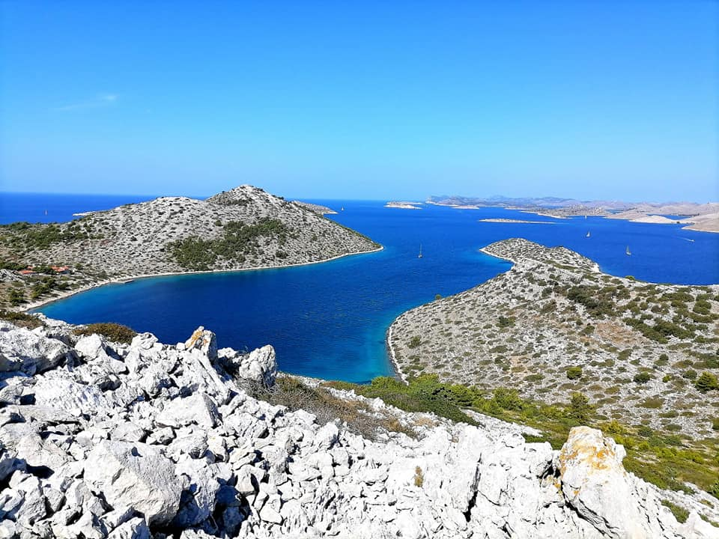
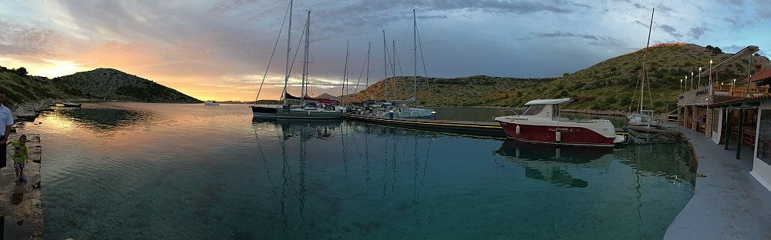
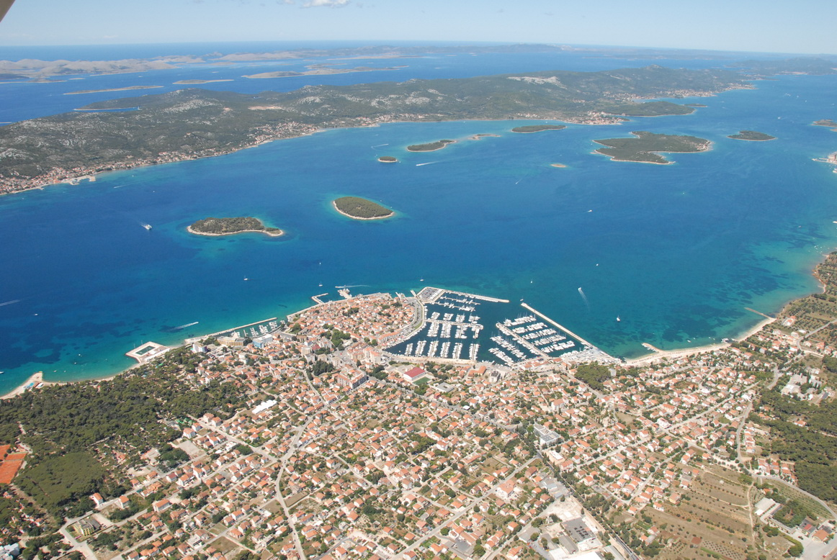
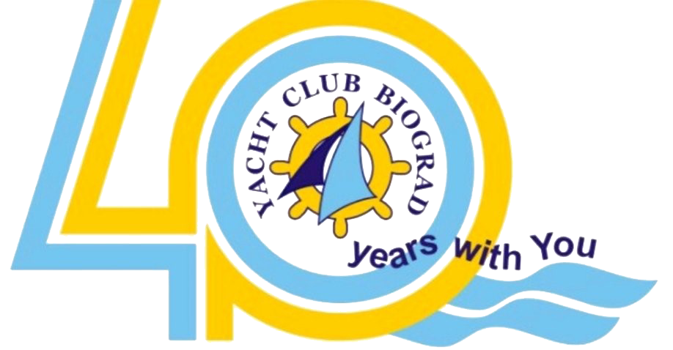
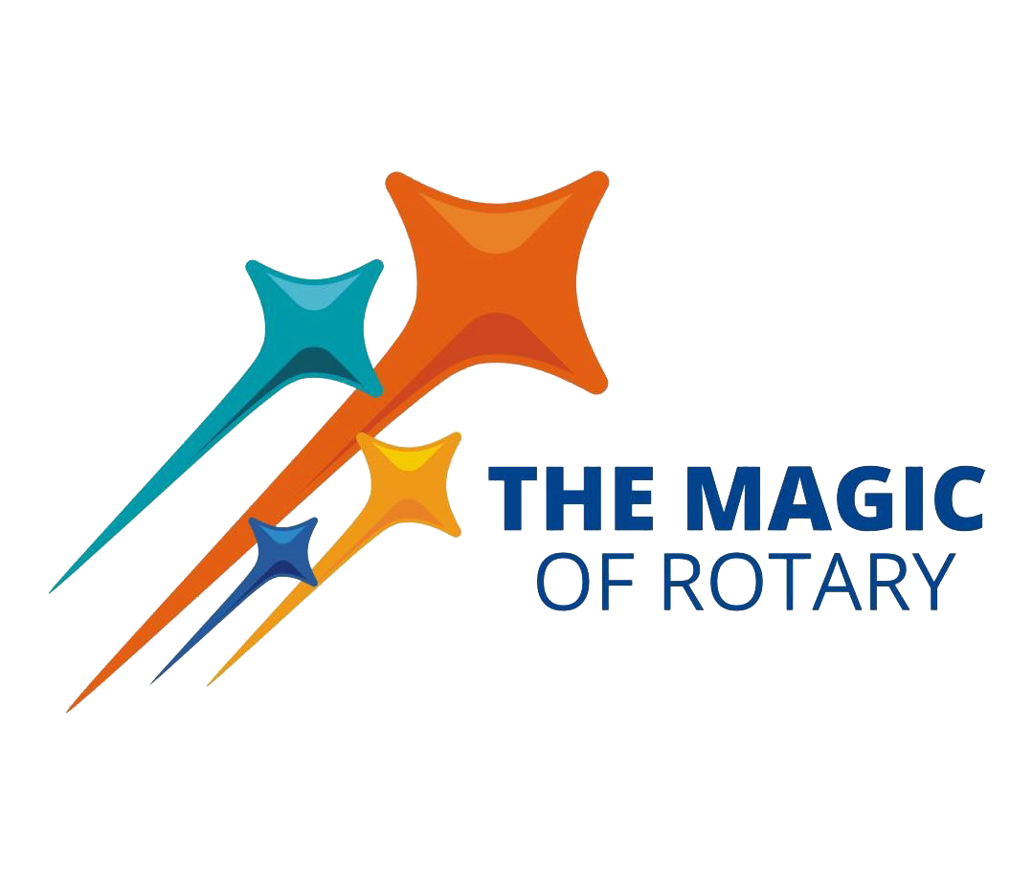
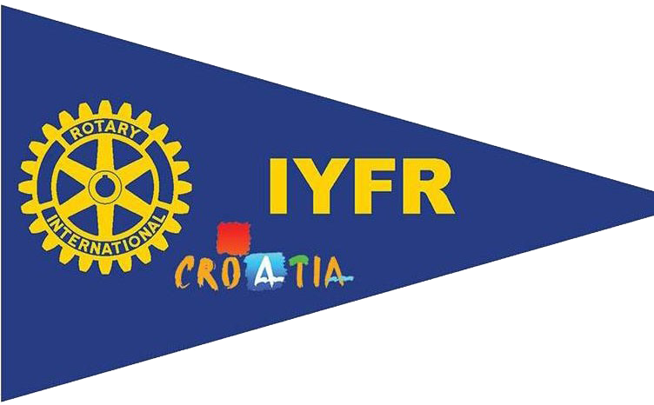


Gordan Borčilo, commodore IYFR Croatia ++385 98 273 088, info@rotary-yachting.com, www.IYFR-Coatia.com

