

I n v i t a t i o n
we invite You to participate

Rotary Charity Regatta B2B
October 19th till 21th, 2023. Biograd-Kornati
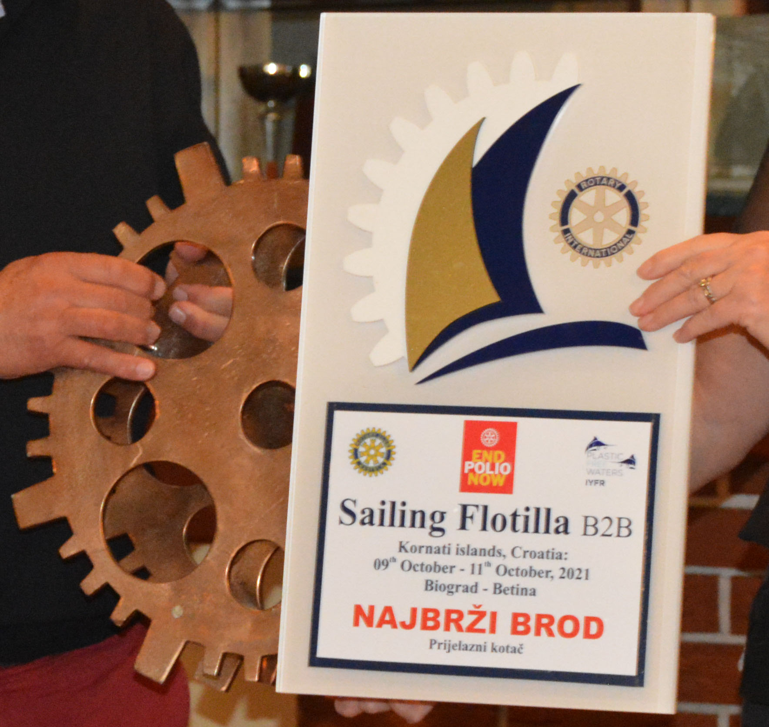
120 trees for 120 rotary years
Saturday, 19th October
16:00 Vinarija Baraka - Vodice / tasting of wine and olive oil - fingerfood 25€
19:00 Regatta opening - Clubs presentation
20:00 Restaurant - opening of the regatta,
presentation, and crew filming, dinner and wine auction, music

Sunday, 15th October
10:00 Marina Biograd - skipper's meeting and start of the regatta
20:00 Sali - Dugi otok, Kornati - dinner, music and lottery

Monday, 16th October
08:30 Sali - skipper's meeting and start of the regatta
18:00 Marina Kornati - dinner, distribution of awards and trophies

Registration fee €190 (01.06:)-217€ till week before regatta, after 280€ per person depending on the date of payment.
Rental Can be arranged through IYFR -Croatia
Payments to: Yacht Club BIOGRAD, 23210 Biograd, Ul. K.P. Svačića 17, p.p. 70, IBAN HR4324070001100568166 swift:OTPVHR2X /
Reference number: Purpose of payment: Registration fee for the regatta

The regatta program is subject to change due to weather conditions.
Organizational committee: Gordan Borčilo, Vladimir Bulić, Dragan Pavelin RC Kaštela, Davor Poljak RC ZG Sesvete, Hrvoje Vojak RC Karlovac, Marko Čićin-Šain RC ZG Metropoliten, Danilo Novakovič RC LJ Zgornji Brnik, Robert Stezinar RC ZG Candor
Applications and information:


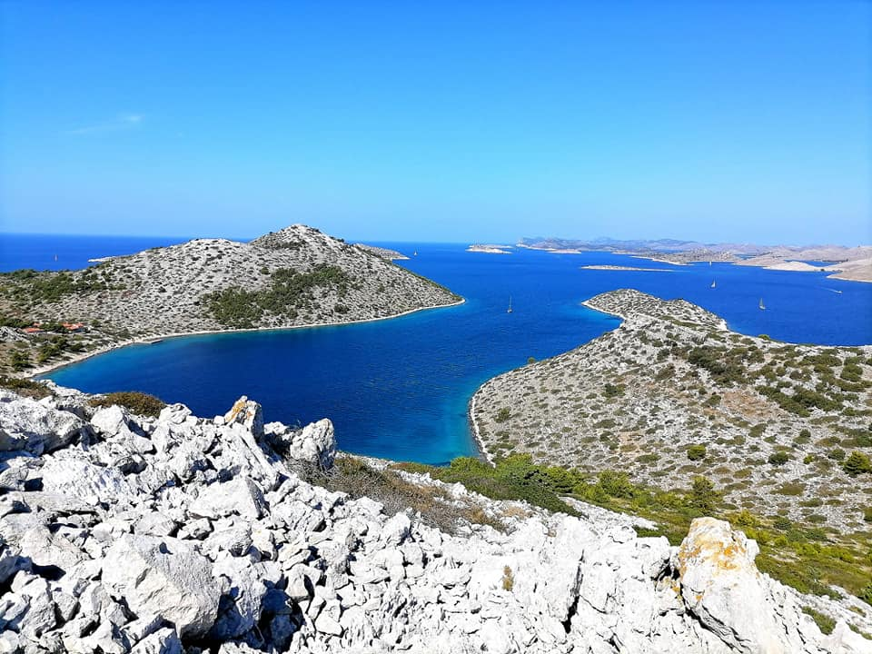
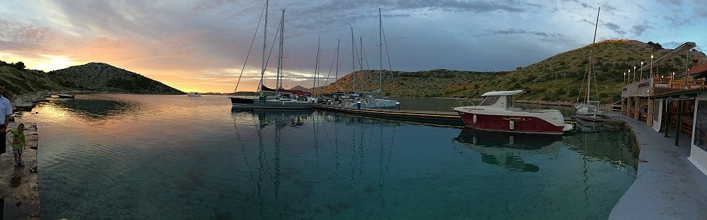
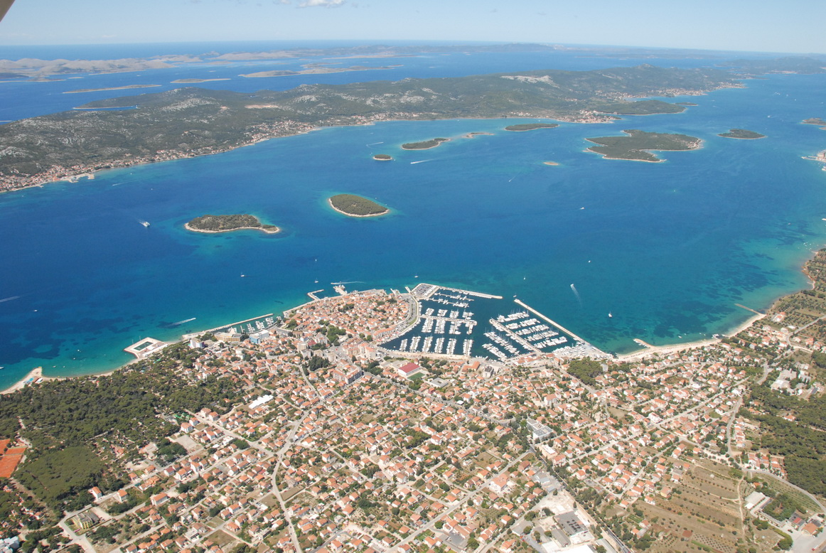
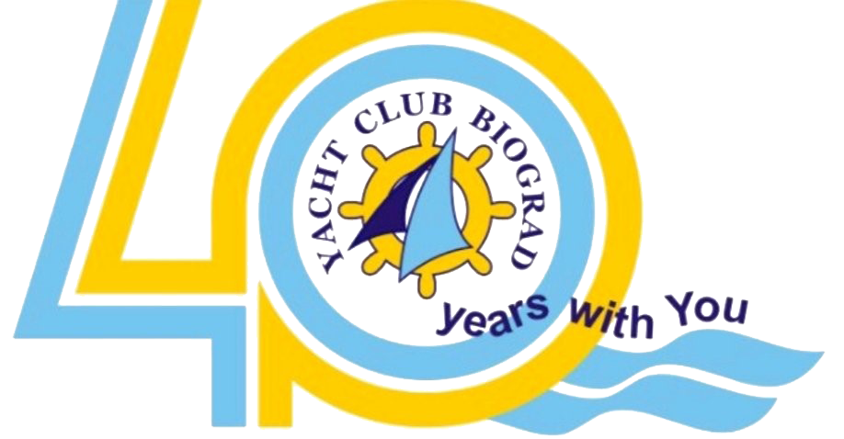

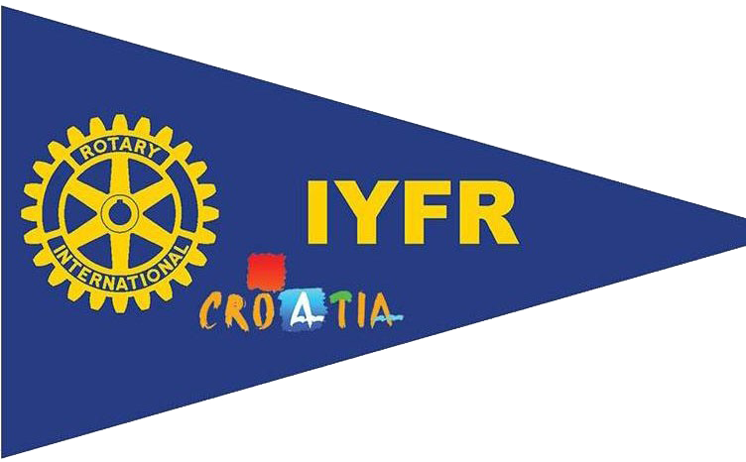


Gordan Borčilo, commodore IYFR Croatia ++385 98 273 088, info@rotary-yachting.com, www.IYFR-Coa

27. Rotary Charity Sailing Flotilla B2B
Kornati islands, Croatia: 19th October – 21th October, 2024
Organizator: Rotary District 1913, Yachting Fellowship, YC Biograd
Humanitarian Aid - www.centar-sv-filipjakov.hr
120 trees for 120 rotary years

PROGRAM
The Rotary clubs of our district, as well as friends from other neighboring districts, and the Yachting Fellowship are involved in the fund-raising campaign to help children in homes. Funds collected from the auction of reproductions of paintings with marine motifs, the wine auction, the lottery, and the income from the regatta will be divided into the aforementioned actions.
We attach great importance and attention to the protection of the Sea and prevention of further pollution.
Microplastics accumulate and pollute life in the sea and on land. It's very simple, let's not throw anything away

Saturday, 19th October Program
14:00 Vinarija Baraka - Vodice / tasting of wine and olive oil - fingerfood 25€
do 17:00 Marina Biograd: registration of crews and ships, division of start numbers, accreditation and payment of entry fee
18:00 "Rotary Gourmet" each club brings a sample of specialties from their region, and presents wines and beers for humanitarian action and lottery
19:00 Opening of Regatta
20:00 Restaurant Biograd: opening of the regatta, presentation and recording of crews, dinner and wine auction
Sunday, 20th October Program
10:00 Marina Biograd - terrace: meeting of skippers
11:00 Start of the regatta - Sali Dugi otak / break, swimming and free sightseeing of the island
15:00 Start of the second race towards island Lavdara, finish in front of the Sali Dugi otok
17:00 Arrival
20:00 dinner, different restaurants, music at the pier

Monday, 21th October Program
08:30 Sali Dugi otok- terrace, meeting of skippers
10:30 Start of the regatta towards the island of Kornati arhipelago / break and refreshment on island Zminjak
13.00 Start of the 4th race finish infornt Biograd
17:00 Marina Biograd - restaurant, dinner, distribution of prizes and cups, music

- The cost of a 3-day program is 190 €uro (217€ payment after Jun 1st, 01.06.) per person. Indication for payments of crew and persons in the Application. The price includes 3 dinners, music, organizational and regatta costs, cups and prizes, embroidery, humanitarian goal of the regatta. The cost of berth, meals on board and parking in the marina is not included in the price.
- Payments to: Yacht Club BIOGRAD, 23210 Biograd, Ul. K.P. Svačića 17, p.p. 70, IBAN HR4324070001100568166 swift:OTPVHR2X / Purpose of payment: Regatta registration fee
As a confirmation of the application for participation in the Regatta, each crew must pay the amount of € 100 per crew member, in case of cancellation they do not return
- Boat rental is not included, good prices through the organizers. Please make reservation befor season to get bettter boats and price

Honorary Committee: Honorary Committee: Boris Ninić PC IYFR Croatia, Danijel Jozić PDG Hrvatska 1913, Velibor Zolak PDG 2483 Srbija i Crna Gora, Jovan Velja Commodore IYFR Srbija,
Race Committee: Gordan Borčilo, Dragan Penjalov
Organizational committee: Gordan Borčilo, Vladimir Bulić, Dragan Pavelin RC Kaštela, Davor Poljak RC ZG Sesvete, Hrvoje Vojak RC Karlovac, Marko Čićin-Šain RC ZG Metropoliten, Danilo Novakovič RC LJ Zgornji Brnik, Robert Stezinar RC ZG Candor
Information & registration:
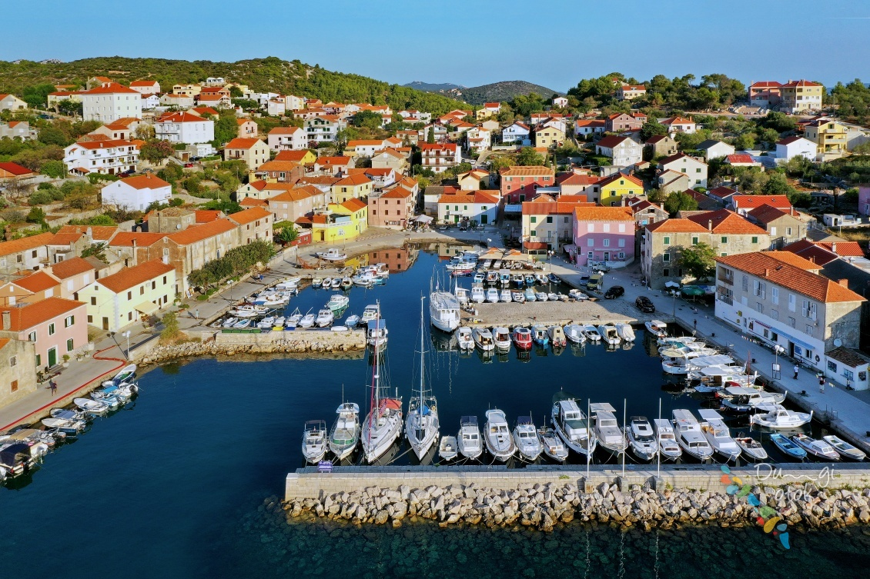


Gordan Borčilo, commodore IYFR Croatia ++385 98 273 088, info@rotary-yachting.com, www.IYFR-Croatia.com

