

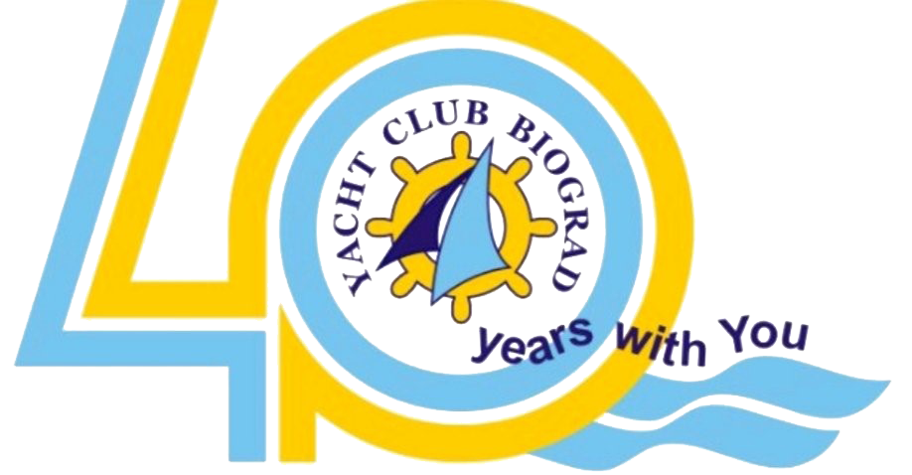
Rotary Charity Sailing Regatta
Humanitarni program: Dom za djecu bez roditelja i dom za rehabilitaciju
Kornati islands, Croatia: 19th October – 21th October, 2024

ENTRY FORM /PRIJAVA - JEDRILICA / YACHT

Ime / Name: Tip / Type: LOA: m

Regist. broj / Registered number: Broj na jedru / Sail number:

BROJ VINJETE ZA 2023. / VIGNETTA NUMBER:

OPEN razvrstanje / OPEN rating: Loa:= c= s / Nm Grupa / Group:

ROTARY CLUB:
Application for tree planting in the campaign 120 trees for 120 years rotary..................................................................................................120€

We will hold a presentation of the club and our place with brochures
and food........................................................................................................

Kormilar / Helmsman: Verifikacija/Verification Nr.:
Adresa / Address:
Tel.: Fax: e-mail:
Klub / Club: Dozvola / Licence nr.:
Članovi / Members:
E-mail Telefon/Telephone nr.: Verifikacija/Verification No.:

- 1,
2.
3.
4.
5.
6.
7.
8.

Competitors participate in regattas at their own risk. The Organizer disclaims any liability for any damage or accident of a competitor, sailboat or third party during the race.
Along with a valid navigation permit and a valid insurance policy, I declare that the ship is equipped and capable of sailing according to applicable regulations and sea conditions.
I declare that I am liable for the damage that may occur to persons and objects during the race in this regatta.

I declare that I take full responsibility for the damage to persons and objects that may occur due to my participation in this regatta.

Datum / Date:___________________ Potpis / Signature:_____________________

